SIMATS ENGINEERING (SAVEETHA SCHOOL OF ENGINEERING)
Department of Computer Science and Engineering
CO2 Assessment Tool 2 — Architecture Design Assignment
Architecture Design Report
Smart Parking Management Platform
Course Code | CSA10 / CSA1063 | Course Title | Software Engineering
CO Assessed | CO2 | Weightage | 20%
Student Name | M.Ravi kiran | Reg. No. | 192325086

1. System Requirement Analysis

1.1 Problem Overview and System Objectives
Urban parking facilities suffer from inefficient space utilization, traffic congestion, and long vehicle queues because real-time parking information is not available to drivers. Drivers spend considerable time searching for vacant spaces, which increases fuel consumption and environmental pollution, and existing parking systems generally depend on manual monitoring or isolated sensors without centralized coordination. The Smart Parking Management Platform is proposed as a distributed system that integrates IoT parking sensors, cameras, and mobile applications to monitor space availability in real time, automatically reserve spaces, predict occupancy trends, recommend nearby available locations, support digital payments, notify users, and generate utilization reports for operators.
The key system objectives are:
- Monitor parking occupancy continuously across all connected facilities.
- Optimize allocation of parking spaces to reduce search time and congestion.
- Predict parking demand using historical and real-time occupancy data.
- Enable online/mobile reservation and digital payment for parking spaces.
- Generate utilization analytics and reports for parking operators.

1.2 Functional Requirements
- Real-time detection and reporting of parking space occupancy using IoT sensors and cameras.
- Space reservation, allocation, and cancellation through the mobile application.
- Recommendation of the nearest available parking location based on driver position.
- Digital payment processing for reservations and parking sessions.
- Automated notifications for reservation confirmation, reminders, and expiry.
- Demand prediction using historical occupancy patterns and machine learning models.
- Operator dashboard for monitoring occupancy and generating utilization reports.
- User account management, authentication, and role-based access control.

1.3 Non-Functional Requirements
- Scalability — the platform must support an increasing number of parking facilities, sensors, and concurrent users without degradation in service.
- Real-time performance — occupancy updates and reservation confirmations must be processed with minimal latency.
- Reliability and availability — the system must remain operational continuously, since drivers rely on it for time-sensitive decisions.
- Security — user data, payment transactions, and sensor communication must be protected against unauthorized access.
- Maintainability — individual functions should be independently updatable as sensor technology or business rules evolve.
- Interoperability — the platform must integrate with third-party payment gateways, mapping services, and diverse IoT hardware.

1.4 Key Quality Attributes Influencing the Architecture
Because the platform continuously ingests high-frequency sensor and camera data while simultaneously serving reservation, payment, and analytics requests, the architecture must place equal emphasis on scalability, reliability, availability, performance, security, and maintainability. These attributes directly influenced the choice of a distributed, service-oriented architectural style described in the following section.

2. Selection of Suitable Software Architecture

2.1 Selected Architectural Style
A Hybrid Architecture combining Microservices Architecture with an Event-Driven Architecture (EDA) is selected for the Smart Parking Management Platform. Business capabilities such as reservation, payment, user management, and analytics are implemented as independent microservices, while the continuous, high-frequency data generated by IoT sensors and cameras is handled through an event-driven message broker that decouples data producers from consumers.

2.2 Justification
- Independent scalability: Each microservice (for example, the Occupancy Prediction Service or Reservation Service) can be scaled independently based on demand, which is essential since sensor-ingestion load and reservation load do not grow at the same rate.
- Real-time data handling: An event-driven backbone (MQTT for lightweight sensor communication and Kafka for durable event streaming) is well suited to the continuous, asynchronous stream of occupancy events produced by thousands of sensors and cameras.
- Loose coupling and fault isolation: Services communicate through well-defined APIs and events, so a failure in one service, such as the Notification Service, does not bring down reservation or payment processing.
- Technology flexibility: The Occupancy Prediction Service can use machine learning frameworks distinct from the transactional services, which is difficult to achieve cleanly in a single monolithic codebase.
- Support for third-party integration: Payment gateways, SMS/push notification providers, and mapping APIs can be integrated at the service boundary without affecting the rest of the system.
Alternative styles were considered and rejected as the primary style for the following reasons: a purely layered monolithic architecture would not scale independently under uneven load and would slow down releases as the system grows; a pure client-server model does not provide the asynchronous, high-throughput event handling needed for continuous sensor data; and a fully serverless approach was set aside as the sole style because sustained, high-frequency sensor ingestion is generally more cost-predictable and latency-stable on persistently running services, although serverless functions may still be used for bursty, infrequent tasks such as periodic report generation.

3. Software Architecture Diagram
The diagram below illustrates the overall structure of the proposed system: the client layer, API gateway, microservices layer, the event bus that carries real-time sensor data, the data layer, and the external third-party systems the platform integrates with.
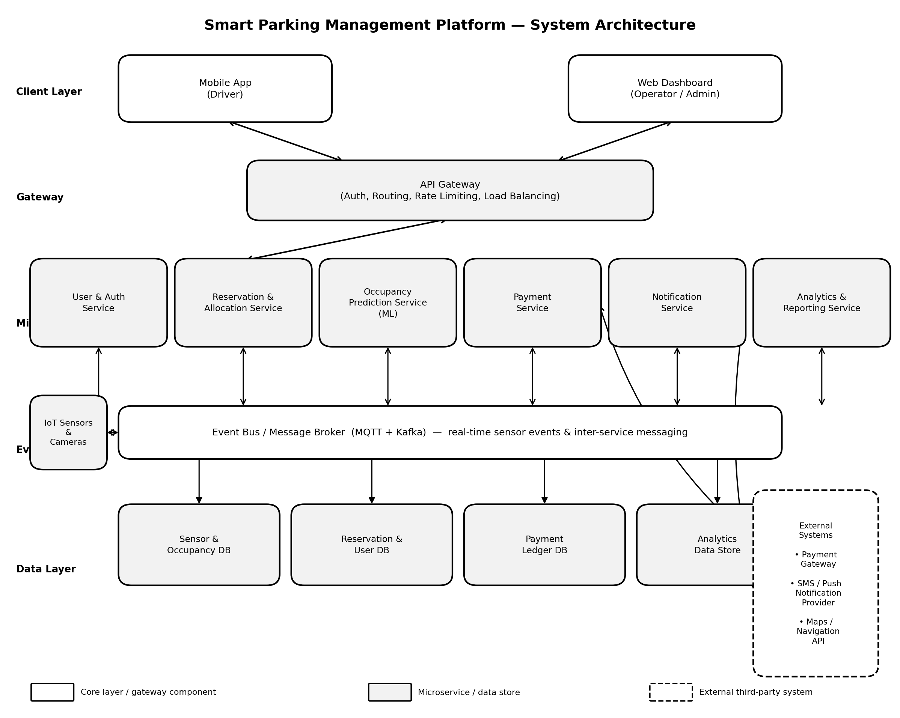
Figure 1: Hybrid Microservices and Event-Driven Architecture of the Smart Parking Management Platform

4. Components and Their Interactions

4.1 Component Responsibilities
Component | Responsibility
Mobile App (Driver) | Client application for drivers to search, reserve, pay for, and navigate to parking spaces, and receive notifications.
Web Dashboard (Operator) | Interface for parking operators/administrators to monitor occupancy, manage facilities, and view utilization reports.
API Gateway | Single entry point that handles authentication, request routing, load balancing, and rate limiting for all client requests.
User & Auth Service | Manages user registration, login, roles, and access control across the platform.
Reservation & Allocation Service | Handles space search, reservation creation/cancellation, and allocation logic to avoid double-booking.
Occupancy Prediction Service | Applies machine learning models to historical and real-time occupancy data to forecast demand and space availability.
Payment Service | Processes digital payments for reservations and parking sessions via an external payment gateway.
Notification Service | Sends reservation confirmations, reminders, and expiry alerts through SMS/push notifications.
Analytics & Reporting Service | Aggregates occupancy and usage data to generate utilization reports for operators.
Event Bus / Message Broker | MQTT/Kafka-based backbone that carries real-time sensor events and asynchronous inter-service messages.
IoT Sensors & Cameras | Edge devices installed at parking spaces that continuously detect occupancy and publish status events.
Data Layer (Sensor, Reservation, Payment, Analytics DBs) | Persists occupancy history, reservations, user data, payment records, and aggregated analytics.
External Systems | Third-party payment gateway, SMS/push notification provider, and maps/navigation API consumed by the microservices.

4.2 Communication and Workflow
Drivers interact with the platform through the Mobile App, and operators through the Web Dashboard; both route every request through the API Gateway, which authenticates the request and forwards it to the appropriate microservice over synchronous REST/HTTPS calls. IoT sensors and cameras publish occupancy status changes continuously and asynchronously to the Event Bus using the lightweight MQTT protocol; the Occupancy Prediction Service and Reservation & Allocation Service subscribe to these events through Kafka to keep availability data current.
When a driver requests a reservation, the Reservation & Allocation Service checks predicted and real-time availability, reserves the space, and publishes a reservation-created event; the Payment Service then processes payment through the external payment gateway, and on success the Notification Service consumes the event and sends a confirmation to the driver. As the reservation nears expiry, a scheduled event triggers the Notification Service to alert the user. All transactions and occupancy events are simultaneously persisted to their respective databases and streamed to the Analytics & Reporting Service, which aggregates the data into utilization reports for operators. This event-driven, service-to-service communication keeps components decoupled: each service can be developed, deployed, and scaled independently while still participating in a consistent, real-time system.

5. Discussion of Quality Attributes
Quality Attribute | How the Architecture Addresses It
Scalability | Each microservice scales independently (horizontally) behind the API Gateway; the event bus buffers bursts of sensor traffic, and databases can be partitioned per service so growth in one facility does not impact others.
Security | The API Gateway centralizes authentication (token-based) and rate limiting; service-to-service traffic and sensor communication are encrypted, and payment data is handled through a PCI-compliant external gateway rather than stored directly.
Performance | The event-driven backbone processes sensor updates asynchronously with low latency, and read-heavy operations such as availability lookups can be cached, keeping response times low even under high concurrent load.
Reliability | Loose coupling through the message broker means a failing service does not directly cascade failures to others; durable event logs (Kafka) allow consumers to recover and reprocess missed events after a restart.
Maintainability | Each service has a single, well-defined responsibility and its own codebase and data store, allowing independent updates, testing, and deployment without redeploying the entire platform.
Availability | Redundant service instances behind the gateway, combined with asynchronous decoupling via the event bus, allow the platform to continue accepting sensor data and serving core functions even if a non-critical service is temporarily unavailable.

6. Justification of Architectural Decisions

6.1 Rationale
The hybrid microservices and event-driven style was chosen because the platform has two fundamentally different workloads: high-frequency, asynchronous sensor/camera events, and transactional, request-response operations such as reservations and payments. Separating business capabilities into microservices allows each to be scaled, deployed, and maintained according to its own load pattern, while the event bus provides the throughput and decoupling required for continuous IoT data ingestion, which a purely synchronous client-server or monolithic layered design could not handle efficiently at scale.

6.2 Trade-offs Considered
- Operational complexity: managing many independent services, an event broker, and multiple databases requires more sophisticated deployment, monitoring, and orchestration (e.g., containers and an API gateway) compared to a monolith.
- Eventual consistency: because services communicate asynchronously through events, some data (such as an occupancy count shown to a driver) may be momentarily stale; this was accepted because near real-time accuracy is sufficient for parking guidance.
- Development overhead: defining clear service boundaries and event contracts up front takes more initial design effort than a single codebase, but this cost is offset by long-term flexibility.

6.3 Support for Future Enhancements and Long-Term Maintainability
The chosen architecture supports future growth in several ways. New capabilities, such as dynamic pricing or EV-charging space management, can be added as new microservices that subscribe to existing occupancy events without modifying existing services. Additional parking facilities and sensor types can be onboarded by connecting new publishers to the event bus, and the platform can integrate new external systems, such as additional payment providers or city traffic-management platforms, at the service boundary. Because each service is independently deployable and owns its own data, teams can maintain, test, and upgrade individual components over time with minimal risk to the overall system, giving the platform strong long-term maintainability and integration potential.

